Shandong C.I.R.S Garments Co., Ltd
Mishui Industrial Park, Xingfu Road,, Gaomi City, Shangdong Province, China
Email: qiuyu@cirsgarments.com
http://www.cirsgarments.com/

Letter of Declaration

The Particle filtering half mask, model#LSD008 is manufactured by Shandong C.I.R.S Garments Co., Ltd

The model meets the eligibility criteria 3 in the April 3, 2020 EUA for non-NIOSH approved respirators made in China. The model is added to Appendix A as an authorized respirator based on above criteria by FDA.
https://www.fda.gov/medical-devices/coronavirus-disease-2019-covid-19-emergency-use-authorizations-medical-devices/personal-protective-equipment-euas#appendixa

The respirator is authorized to be distributed to and used in healthcare settings by HCPs when used in accordance with CDC’s recommendations under this EUA, despite the fact that they do not meet certain requirements otherwise required by applicable federal law.

User Manual
Particle filtering half maskLSD008 FFP2 NR
Following standard: EN 149:2001+A1:2009 Regulation (EU)2016/425

Use Instruction
1. Failure to follow all instructions and limitations could seriously reduce the effectiveness of this particle filtering half mask and could lead to illness, injury or death.
2. A properly selected respirator is essential, before occupational use, the wearer must be trained by the employer in the correct use of the respirator in accordance with applicable safety and health standards.
3. This particle filtering half mask does not supply the oxygen. Use only in adequately ventilated are as containing sufficient oxygen to support life.
4. Discard the respirator and replace with a new one if excessive clogging of the particle filtering half mask cause breathing difficulty or the particle filtering half mask becomes damaged
5. Leave the contaminated area if dizziness, irritation or other distress occurs

Warning
1. Do not use the respirator or enter or stay in a contaminated area under the following circumstance:
a) Atmosphere contains less than 19.5% oxygen.
b) If you smell or taste contaminant
c) For protection against gases or vapors
d) Contaminants or their concentrations are unknown or immediately dangerous to life or health.
e) For sandblasting, paint-spray operations and asbestos.
f) In explosive atmospheres
2. Do not modify or misuse the mask.
3. Do not use the particle filtering half mask with facial hair or any other conditions that may prevent a good face-seal, the requirements for leakage will be achieved.
4.Pleasecheckpriortousingtoensure：The head harness is attached well； The nose clip and sponge are attached properly on the mask.
5. This respirator helps protect against certain particulate contaminants but does not eliminate exposure to the risk or contracting disease or infection. Misuse may result in sickness or death
6. This particle filtering half mask marked “NR”, shall not be used for more than one shift

Fitting
- Place under chin and press the mask freely against your face with the nose clip on the bridge of your nose
2.Pull the head harness behind to ears, attach the head harness to the retaining clip.
3.Adjust the retaining clip to improve comfort and prevent leakage
4.Please adjust the nose clip to the shape of the nose by squeezing it to the face with both hands.
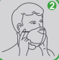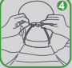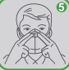
5.To check for proper fit，cup both hands over the mask and exhale vigorously. If air leaks around the nose, tighten the nose clip，if air leaks around the edge， reposition the head harness for better fit.
6.Entry into a contaminated area with an improper fitting mask may result in illness or death.

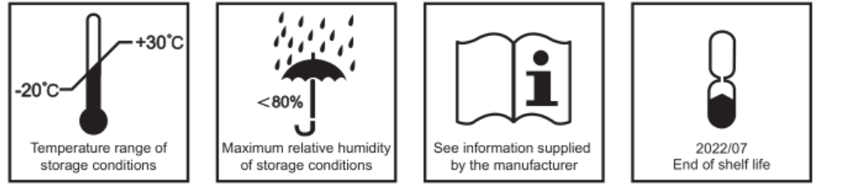
A copy of the Declaration of Conformity will be supplied with every smallest commercially available package

Notified Body:CCQS Certification Services Limited
NB:2834
Address: Block 1 Blanchardstown Corporate Park, Ballycoolin Road, Blanchardstown, Dublin 15 D15 AKK1, Dublin Ireland (NB2834)
Manufacture：Shandong C.I.R.S Garments Co., Ltd.
Address: Mishui Industrial Park Xingfu Road, Gaomi City, Shandong Province, P.R. China

